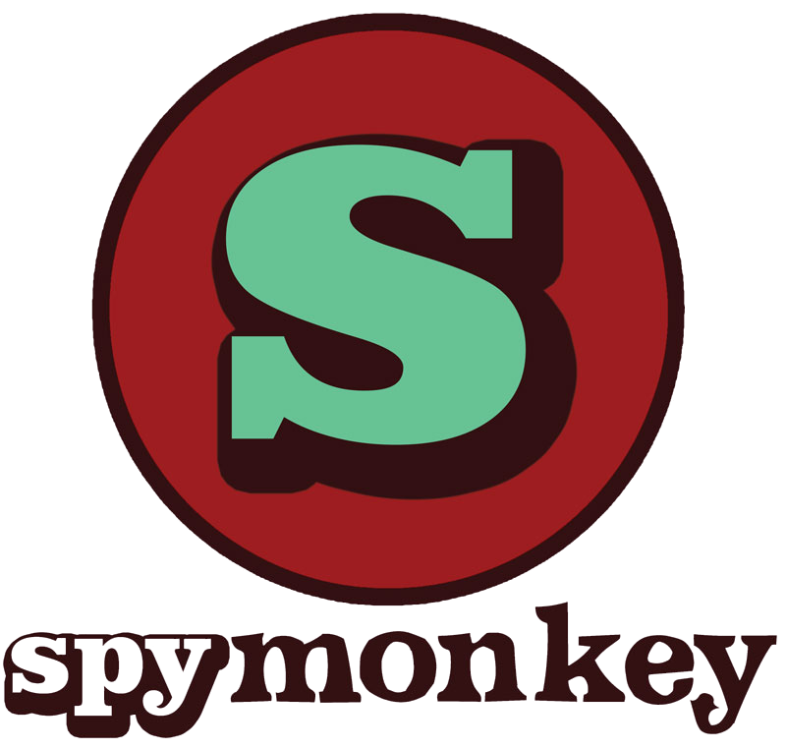

Bursary Scheme

Application Information

About Spymonkey's Workshops

Since our inception in 1998, Spymonkey have created some of the most outstandingly original theatre in Britain, drawing on the disciplines of clown, physical theatre and devised theatre.

We are committed to supporting the development of the next generation of comedy performers. Our professional training workshops are delivered by the artistic directors and associate artists in the UK and across the world. Participants develop techniques of clowning, comedy, devising and music theatre in a way which is transferrable to their own practice. We also offer practical sessions on the business of making and touring a show.

'Best workshop I've ever done. Safe but playing with risk. light but deep, and FUN! so much fun!" Amy Saunders / Miss Behave - performer (La Clique, La Soirée, MBGS Las Vegas)

"Belly-laughter, support, ideas, and real friendships. Definitely returning for future sessions. Highly recommended for those new to clowning, as well as for old hands.” Vera Chok performer, Malaysia/London

“If you ever get a chance to embark on a Spymonkey clowning workshop- be brave and jump at it - no red noses or big flappy feet required.” Gemma Rogers singer/songwriter, performer

“This course will give you the insider tips and tricks to creating something joyful together. It changed my teaching and it changed my life.” Jess Gill head of drama, St Mary's School Hertfordshire

Spymonkey team up with Tall Stories

This year for the first time we are partnering with Tall Stories theatre company to offer these bursaries.

"At Tall Stories we believe that everyone has the right to see themselves and their stories being represented on stage. We are keen to play our part in addressing the lack of diversity within physical theatre by offering the course free to two individuals from under-represented groups. Together, Spymonkey and Tall Stories are committed to diversifying the next generation of physical theatre and physical comedy performers and look forward to working together on this collaboration.”

Why the Brassmonkey Bursary is needed and who it's for

Having worked with performers and theatre makers in our shows, through our collaborations with other organisations and via our education and training work, we are aware of the lack of diversity in theatre, and within comedy performance in particular. Alongside this, the financial barrier to accessing professional development is a real obstruction for many people. We are therefore keen to play our part in addressing this by offering Brassmonkey Bursary places to people from a diverse background or those who are underrepresented on our stages, on all of our courses.

We recognise the lack of access and options into the industry for people from racialised backgrounds and for our 2021 workshop bursary places we specifically welcome people who have faced barriers to access as a result of either systemic or interpersonal racism such as:

* Black people - those of African heritage, Caribbean heritage, and those who are part of the African diaspora
* South, East, South East Asian and those who are part of the Asian diaspora
* Mixed heritage people and other racially or ethnically marginalised people

Spymonkey Workshop Bursary Scheme application

If you are interested in applying for a bursary place, please complete this short application and return it to us by the date specified on our website (NB this differs depending on the course you are applying for). We will shortlist from applications and hold short calls or Skype/video calls with those people we would like to get to know a little more.

If you would prefer, you can submit your answers as a short video to camera.

This process is designed to be flexible and not overly time consuming, whilst still giving us an idea of you and your experience. If you would like to speak to a member of the Spymonkey team before the application deadline please email education@spymonkey.co.uk

Application Form

NAME:

CONTACT EMAIL: PHONE:

HOME TOWN/CITY:

COURSE FOR WHICH YOU ARE APPLYING:

Please tell us a bit about you and your theatre-making experience.

Tell us why you would like to take part in the Spymonkey course?

Is there a particular area of skill you would like to work on during the workshop?

What’s your funny inspiration?

Please email your applications to education@spymonkey.co.uk (application deadlines listed on our website).

EQUALITY & DIVERSITY MONITORING FORM

Spymonkey are committed to promoting equality and diversity across all its activities. We are interested in working with staff, collaborating with artists and participants and reaching audiences who are underrepresented in the arts sector due to their socioeconomic status, ethnic background or disability. The Brassmonkey Bursary is aimed directly at this area of work.

To ensure that we are properly implementing this when shortlisting, we request that you complete the Equality and Diversity Monitoring Form along with your application.

Name:

GENDER IDENTITY (please tick):

Female (including male to female trans women)

Male (including female to male trans men)

Non-Binary

Prefer not to say

AGE (please tick):

0-19 years 20-34 years 35-49 years

50-64 years 65+ years Prefer not to say

Do you consider yourself to have a disability? (please tick):

No

Yes, how would you describe your disability?

Visual impairment Physical disabilities

Mental health condition Other long term/chronic conditions

Hearing impairment/Deaf Cognitive or learning disabilities

Invisible disabilities

Do you identify as working-class? (please tick)  
 Yes:

No:

ETHNICITY (please tick):

Asian or Asian British

Indian Pakistani

Bangladeshi Chinese

Any other Asian background

Black / Black British

African Caribbean

Any other Black background

Mixed

White and Black Caribbean White and Black African

White and Asian Any other Mixed/Multiple ethnic background

White

British Irish

Any other White background

Other

Not known / Prefer not to say

Any other ethnic group

Is there a reason which isn’t listed here why you should be considered for a bursary? Please give information below: